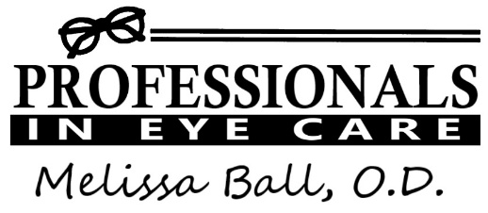
In the wake of COVID-19, we must do all that we can to keep our staff and our patients safe. Until this crisis has passed, we must find new ways of doing things that allow us to continue our activities of daily living without sacrificing our safety. Because of this, we have implemented a number of changes at Professionals in Eye Care. Hopefully most of these changes will be temporary, but for now…

*All patients and staff will be required to wear a mask while they are in the office. If you have a mask, please bring it with you. Our supplies are VERY limited. Cloth masks are acceptable. If you touch your face or rearrange your mask, you will be asked to wash your hands immediately.
*Whenever possible, all paperwork should be filled out in advance. Our goal is to minimize the time you spend in our office, which will decrease the likelihood that you will encounter other patients who could be contagious.
*We no longer have a traditional waiting room. When you arrive at our office, we ask that you call or text us at 606-877-6585. We will notify you when you may safely enter the building.
*Guests cannot be permitted to enter the building, with the exception of caretakers.
*All patients will be asked to undergo a brief health screening prior to their appointment. Patients who may be contagious will be asked to reschedule.
*We have changed our schedule in an attempt to minimize the number of patients in the office at one time. Because of this, we are seeing less patients per day and you may have to schedule your appointment further in advance than you did in the past.
*Patients who are considered to be “vulnerable,” such as those over age 65, diabetics, people with breathing issues, etc., will be given early morning appointments whenever possible.

Wellness Questions
□ Yes □ No Do you have a cough?
□ Yes □ No Do you have a fever now or have you in the past 3 days?
□ Yes □ No Are you experiencing shortness of breath?
□ Yes □ No Have you traveled outside of the country in the last 2 weeks?
□Yes □ No Have you come in contact with someone experiencing symptoms of COVID-19 in the last 7 days?
Please be advised that if you answer “yes” to any of the questions above you will be asked to reschedule your appointment.

Signature___________________________________________ Date ______________________

Patient Registration Sheet

Name ___________________________________________________________________
Last First MI Nickname

Address__________________________________________________________________

__________________________________________________________________

Phone □__________________ □_________________ □_________________
Home Work Mobile
(Please mark preferred
E-mail □____________________________________________ form of communication)

Do you prefer to receive your exam documents?
□ Online □ Paper copies □ Both

Date of Birth___________________ Age________ SS# ___________________________

Race/Ethnicity________________________Preferred Language____________________

Employer_______________________________Occupation________________________

Health Insurance Company__________________________________________________

Vision Insurance, if applicable_______________________________________________

Marital Status: □ Married □ Single □ Divorced □ Widowed

How did you hear about us?_________________________________________________

If your insurance policy is in someone else’s name, please provide the following information about the person who holds the policy:

Name______________________________________ Date of Birth___________________

Employer___________________________________ S.S.#_________________________

Address (if different from above) ______________________________________________

Phone _____________________ ____________________ ___________________
Home Work Mobile

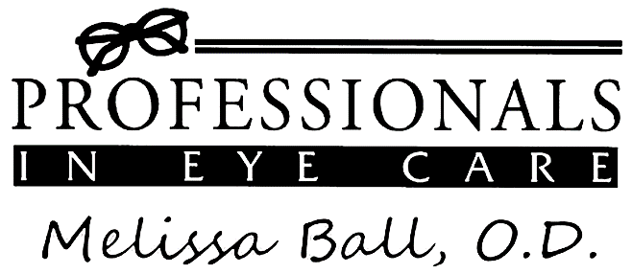

I acknowledge that I was given a copy of the Notice of Privacy Practices from Melissa Ball, O.D. at Professionals in Eye Care.

Signature ________________________________________________________________

Date _______________________

Permission to Disclose to Personal Acquaintances

Please list below any friends, relatives, or acquaintances OUTSIDE YOUR IMMEDIATE FAMILY with whom we may discuss your personal information without prior consent.

______________________________________________________________________

______________________________________________________________________

______________________________________________________________________

Special Requests:
□ Please DO NOT leave a message on my voice mail or answering machine for any reason
□ Please DO NOT share relevant information about my care with my family members

Other : __________________________________________________________________

Authorization for Release of Information
and Payment on my Account

I hereby authorize Professionals in Eye Care to file claims related to my care in this office with the appropriate insurance company. I also authorize the insurance company to send payment on my behalf to this office. I understand that I am responsible for any unpaid amounts not paid by my insurance company. I understand that I am responsible for any unsatisfied annual deductibles and that I will receive a bill for those if I do not pay them at the time of my visit.

My signature on this form shall serve as my signature on file for any and all claims associated with the care which I receive while in this office or under the care of this optometrist.

Signature ________________________________________________________________

Date _______________________
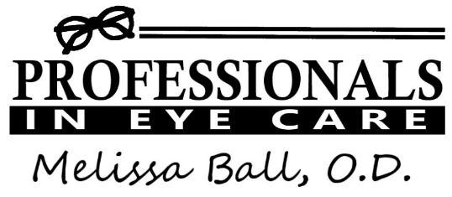
Patient History Form

Name __________________________________________ Date of Birth _____________________

Primary Care Physician / Family Doctor ____________________________________
Pharmacy __________________________________

Medical History
□ Yes □ No Do you suffer from high blood pressure, diabetes, heart disease, thyroid disorder, or any other health issues?
If yes, please explain: _____________________________________________________________________________
□ Yes □ No Have you had any major surgeries, such as gallbladder removal, heart surgery, joint replacement, hysterectomy, prostate surgery, surgery for cancer, etc?
If yes, please explain: ______________________________________________________________________________
Ocular History
□ Yes □ No Do you have any known eye health conditions, such as cataracts, glaucoma, lazy eye or crossed eyes, or macular degeneration?
If yes, please explain: ______________________________________________________________________________
□ Yes □ No Have you ever had surgery on your eyes?
If yes, please explain: ______________________________________________________________________________
□ Yes □ No Have you ever been told that you are a “steroid responder”?
□ Yes □ No Have you ever been told that you have “narrow angles”?
Medications
□ Yes □ No Do you use any eye drops (prescription or over-the-counter) or take any medications for your eyes?
If yes, please list: _________________________________________________________________________________
□ Yes □ No Do you take any medications (prescription or over-the-counter)?
If yes, please bring a list of ALL medications, including dosage, frequency, and reason for use, when you come for your appointment

Allergies
□ Yes □ No Are you allergic to any medications?
If yes, please list: _________________________________________________________________________________
□ Yes □ No Do you have seasonal allergies?
□ Yes □ No Are you allergic to any foods, pets, dyes, or any other substances that you know of?
If yes, please explain: ______________________________________________________________________________
Social History
□ Yes □ No Are you a current smoker?
If so, how many packs per day? ________ How long have your been a smoker? _____________
□ Yes □ No Are you a former smoker?
If so, how long did you smoke? ____________ How long ago did you quit? _____________
□ Yes □ No Do you vape or use smokeless tobacco products?
If yes, please explain: ______________________________________________________________________________
How many times in the past year have you had more than 4 alcoholic beverages in one day? ______
What is your occupation? ____________________________________________________________________________
What do you do in your spare time? ____________________________________________________________________
Family History
□ Yes □ No Does anyone in your immediate family have eye health problems, such as lazy eye, crossed eyes, glaucoma, or macular degeneration?
If yes, please explain: _____________________________________________________________________________
□ Yes □ No Do any health problems, such as high blood pressure, heart disease, diabetes, thyroid disease, cancer, etc, run in your family?
If yes, please list the conditions and who has them: _____________________________________________________
_______________________________________________________________________________________________
Review of Systems
□ Yes □ No Do your eyes burn or itch?
□ Yes □ No Do your eyes get red?
□ Yes □ No Do your eyes ever feel dry?
□ Yes □ No Do your eyes water a lot?
□ Yes □ No Do you ever see double?
□ Yes □ No Do you see flashes of light or floaters?
□ Yes □ No Does your vision get blurry?
□ Yes □ No Do you have a lot of headaches?
If you answered yes to any of the above questions, please provide any additional information you think may be helpful: _____________________________________________________________________________________

Do you have any problems with your….
□ Yes □ No Ears, nose, or throat?
□ Yes □ No Heart or blood vessels?
□ Yes □ No Respiratory system (such as asthma or COPD)?
□ Yes □ No Stomach or intestines?
□ Yes □ No Kidneys, bladder, prostate, or female organs?
□ Yes □ No Muscles or bones?
□ Yes □ No Skin?
□ Yes □ No Glands? (This includes diabetes or thyroid problems)
□ Yes □ No Blood or lymph nodes?
□ Yes □ No Nervous system (such as numbness or tingling)?
□ Yes □ No Immune system (such as sarcoid or lupus)?
□ Yes □ No Do you have any mental health problems, such as depression, anxiety, or attention deficit disorder?
□ Yes □ No Are you generally in good health?
□ Yes □ No If you are female, are you pregnant or trying to get pregnant?
□ Yes □ No Do you have any other health issues that we may need to know about?
If you answered yes to any of the questions above, please elaborate: _______________________________________
________________________________________________________________________________________________
________________________________________________________________________________________________
________________________________________________________________________________________________

